Experiment-2

Create your First AWS S3 Bucket and Upload Content to Bucket

* Go to Aws service S3

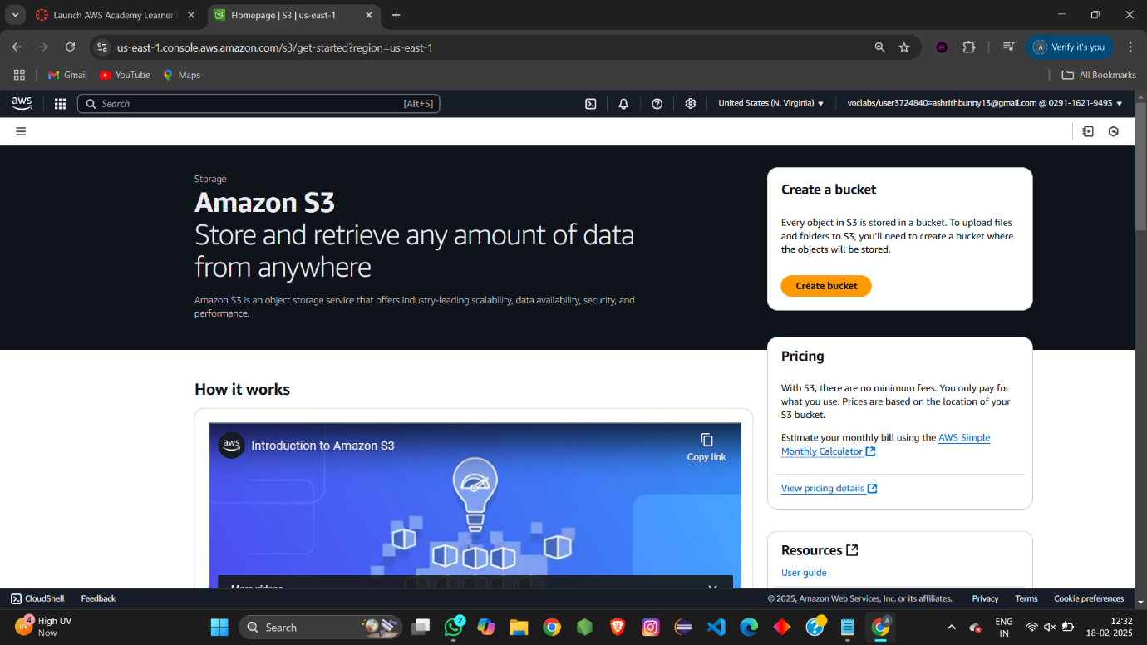

* Create a bucket with your name.

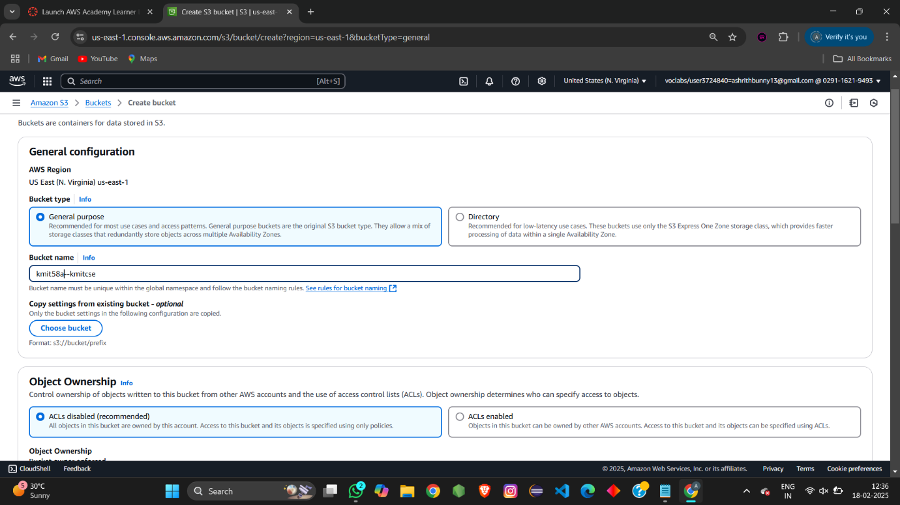

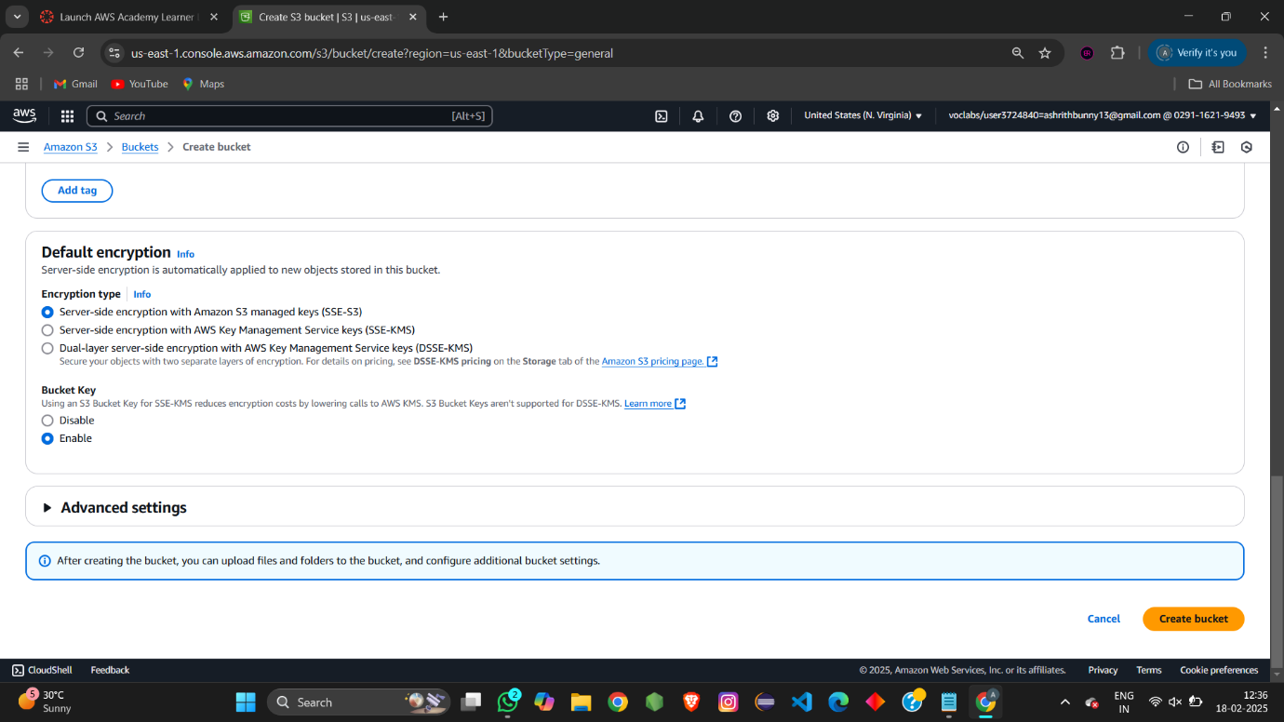

* Bucket get created with name . (donot select anything create it with by default settings)

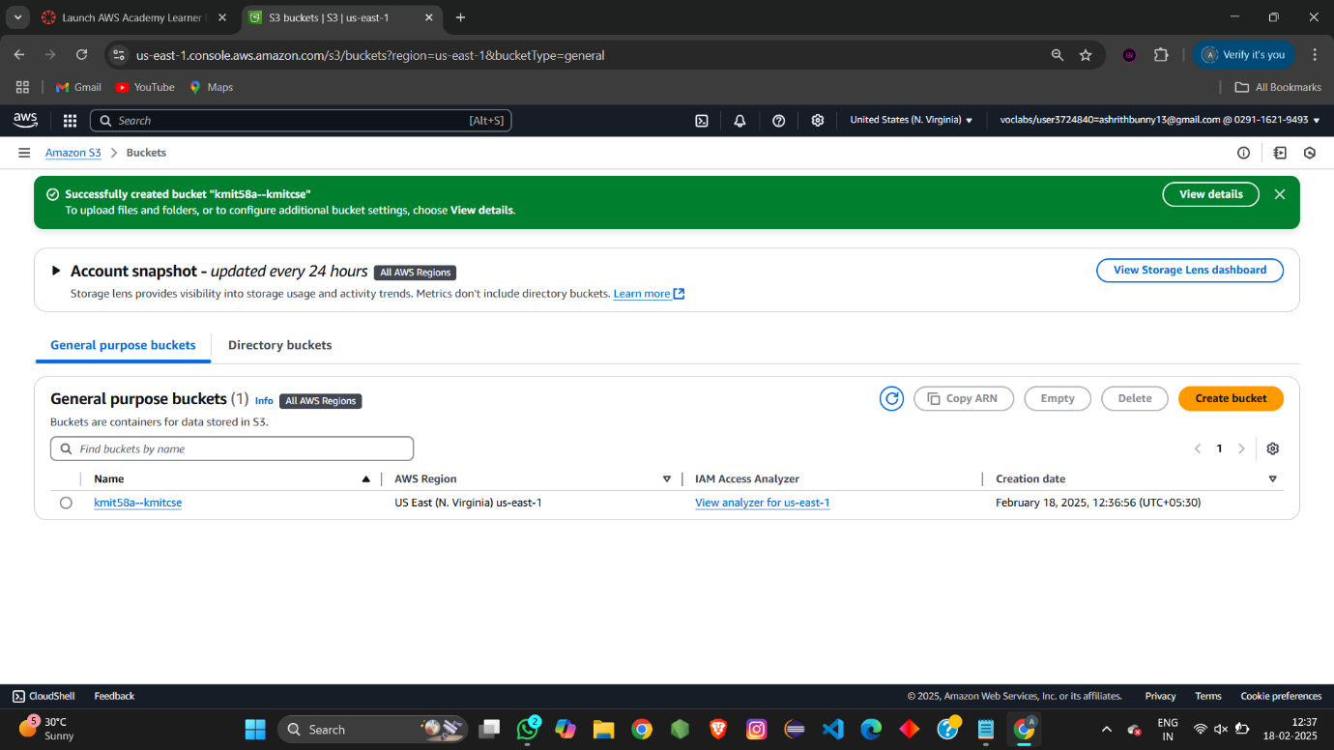

* Upload any file or image i.e Object into the bucket.

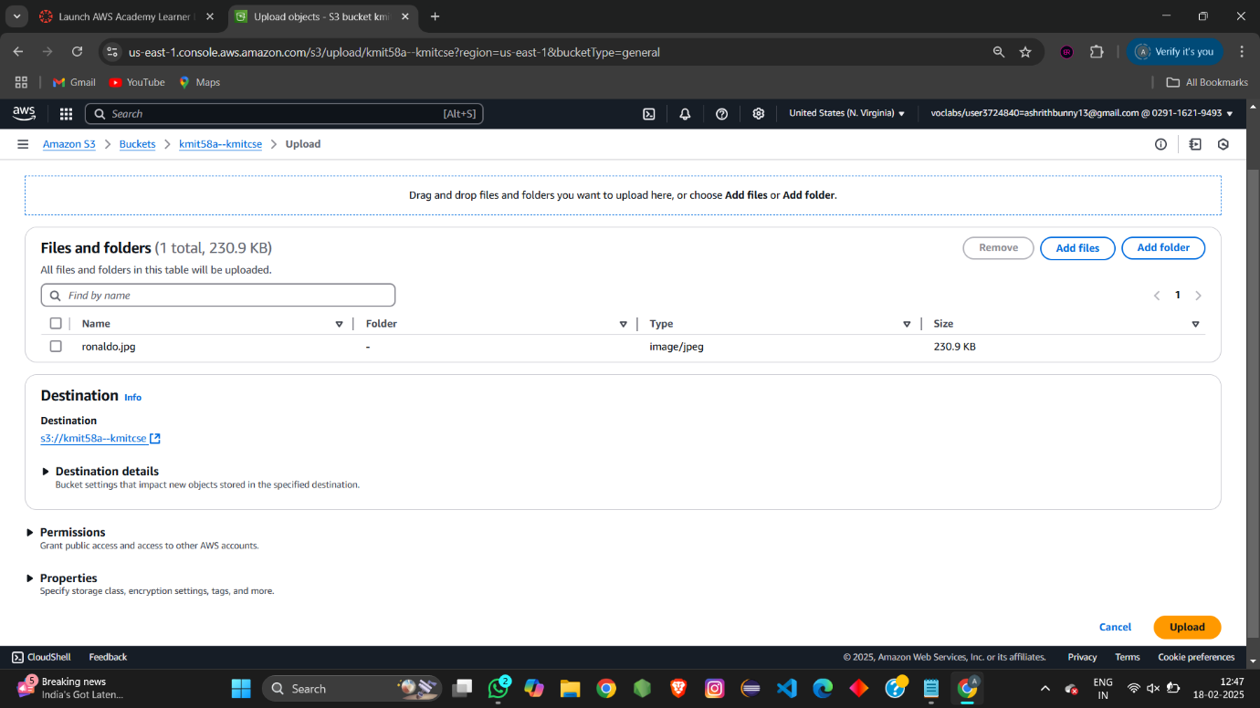

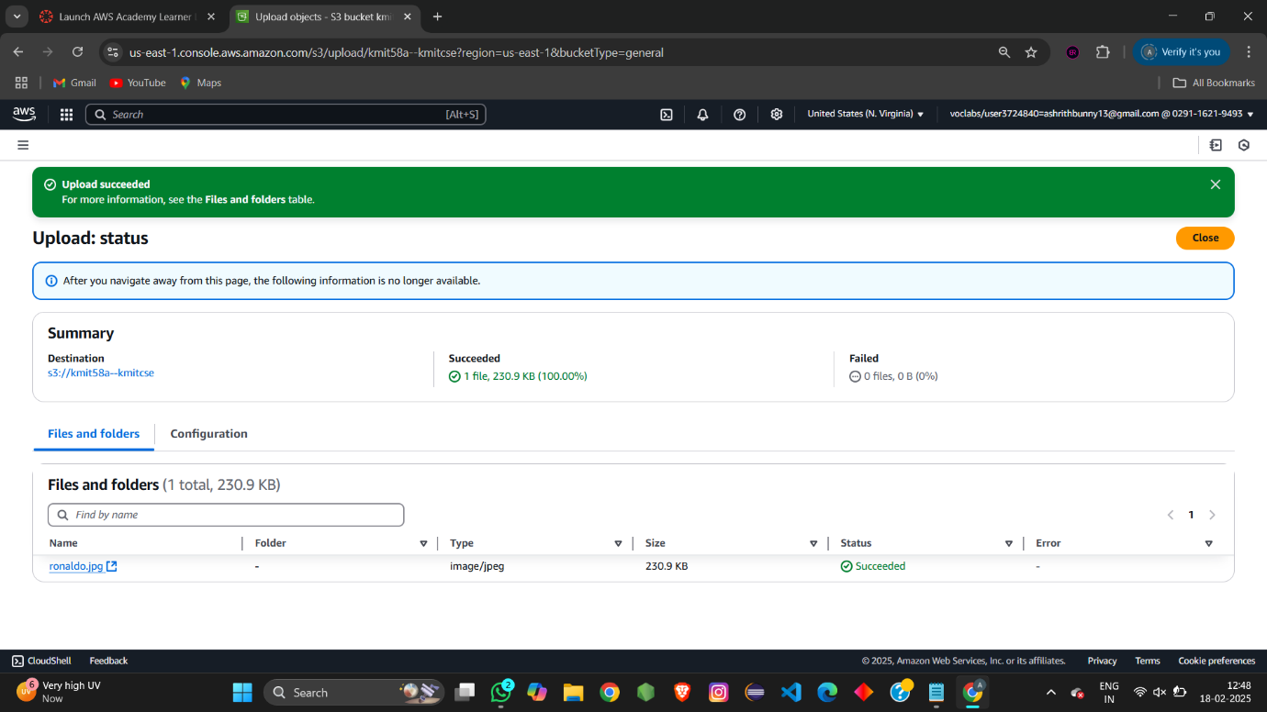

* Now check for the public ip address of the object we can access or not.(ObjectURL)

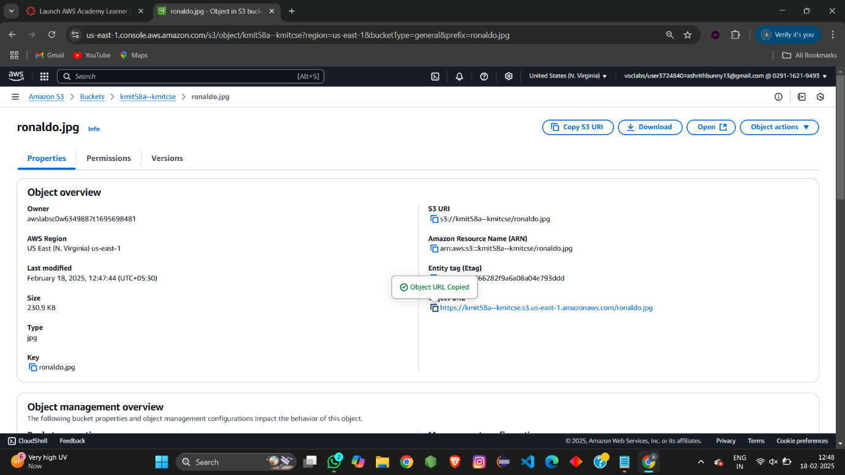

We are unable to access the object

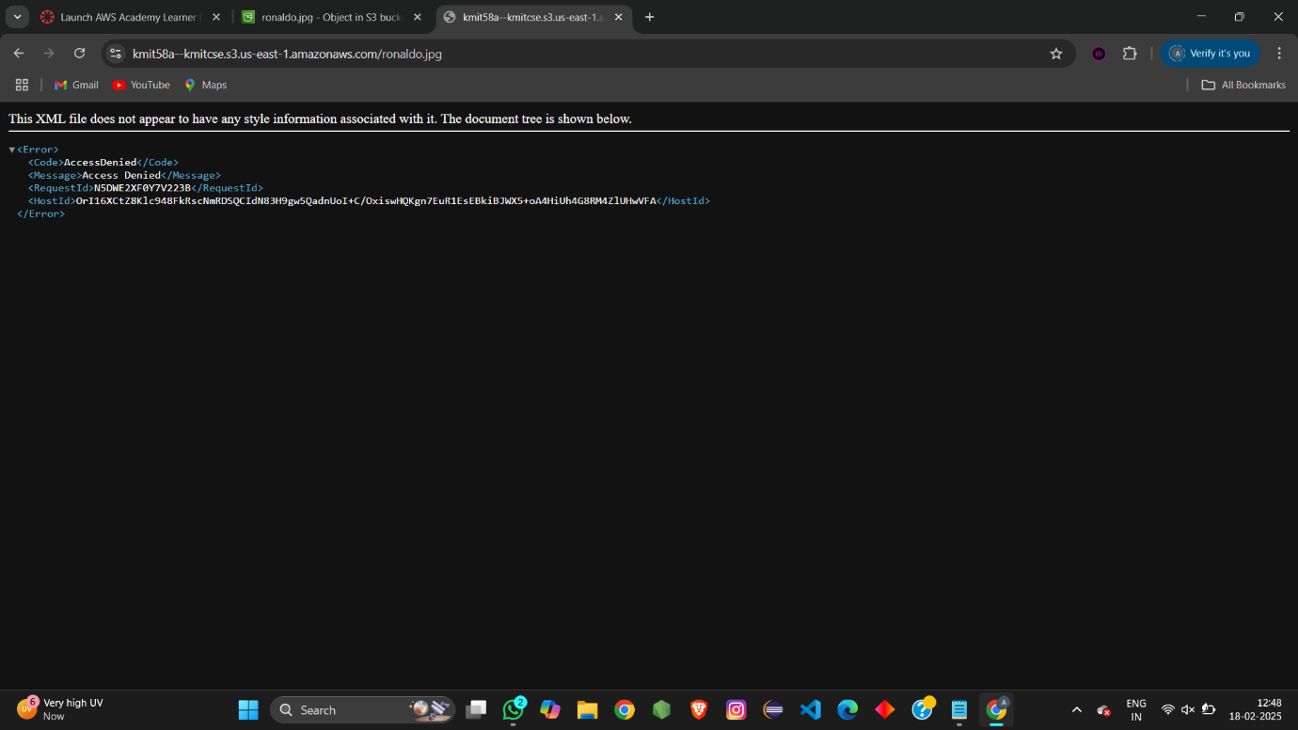

This is because we have created the S3 bucket with default settings.

Now we have change the permission at two levels i.e bucket – level permission,

object – level permission.

Changing of Bucket level permission:

Goto permissions at Bucket level

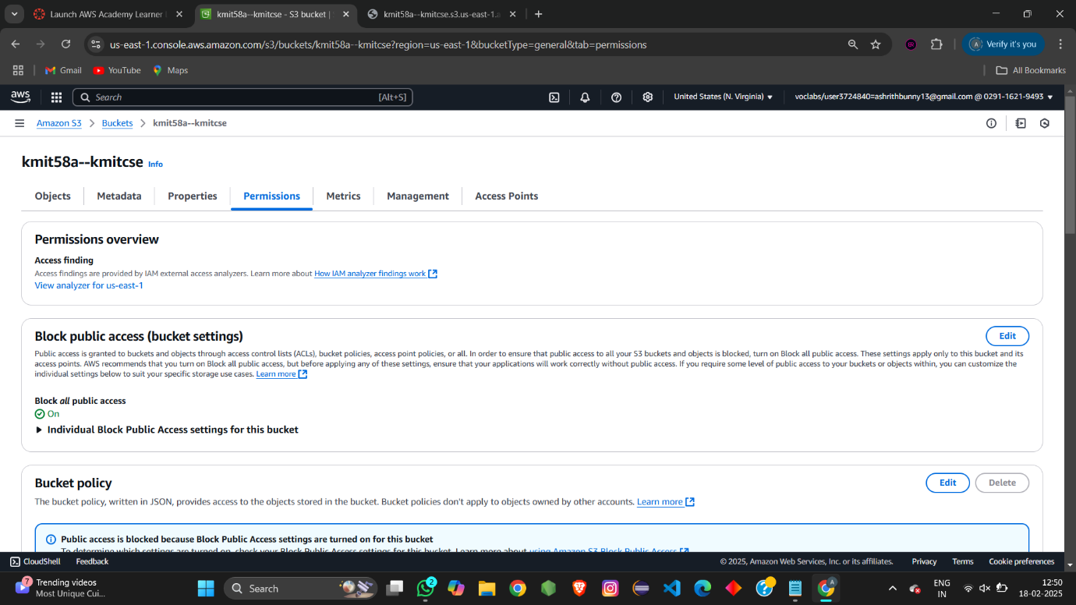

Edit Block public access:



Then save changes

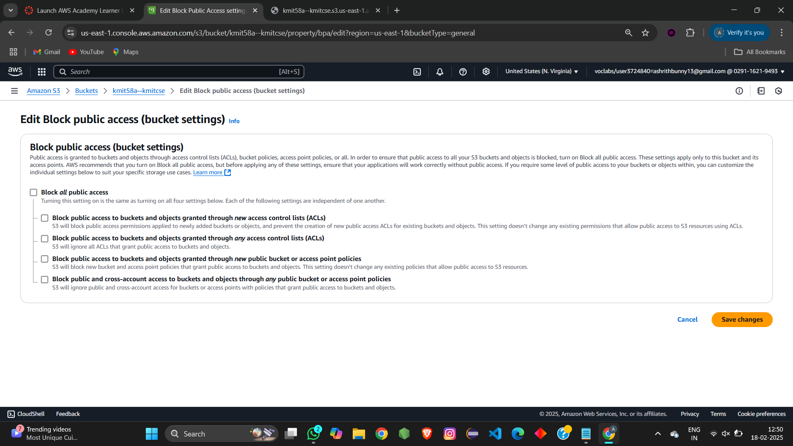

Type “Confirm” it is an acknowledgement to save changes.

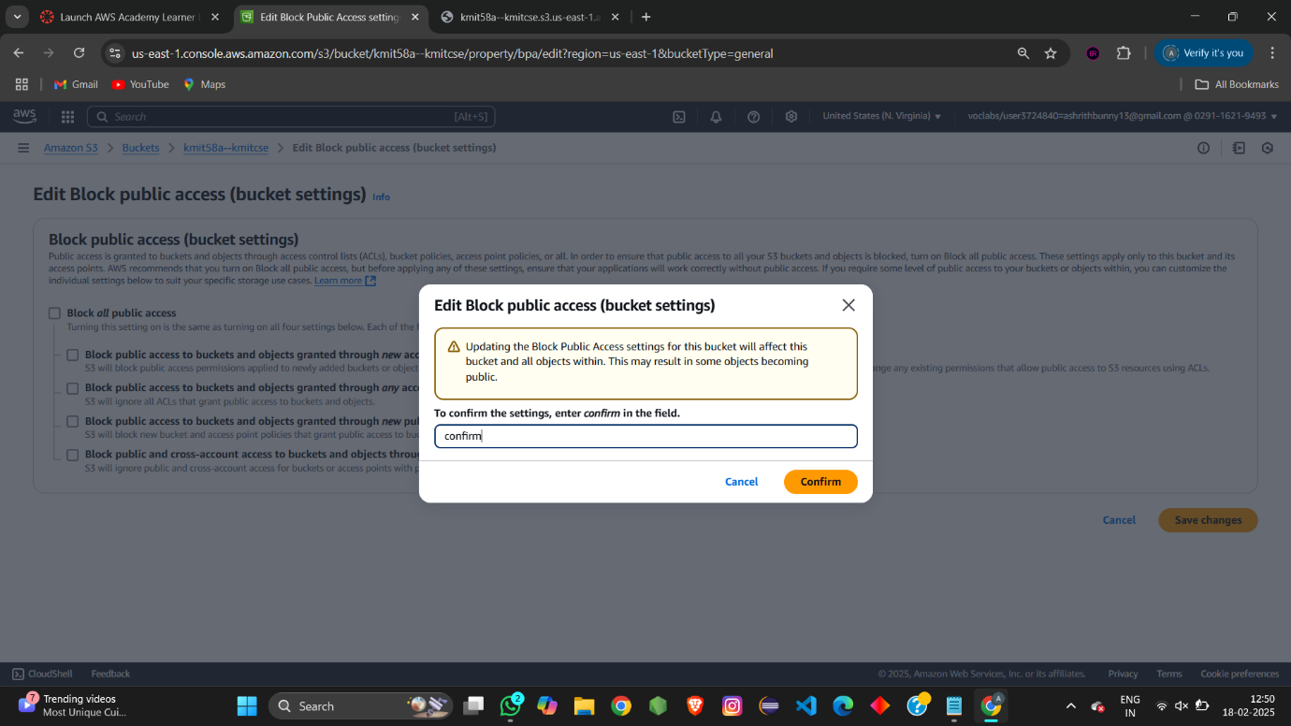

Edit object owernship

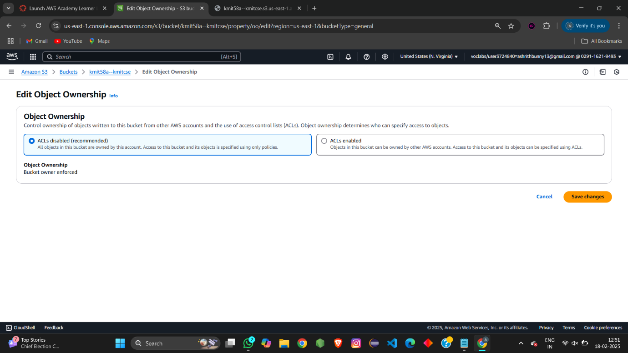

Click on enabled and acknowledge the change. Than save changes

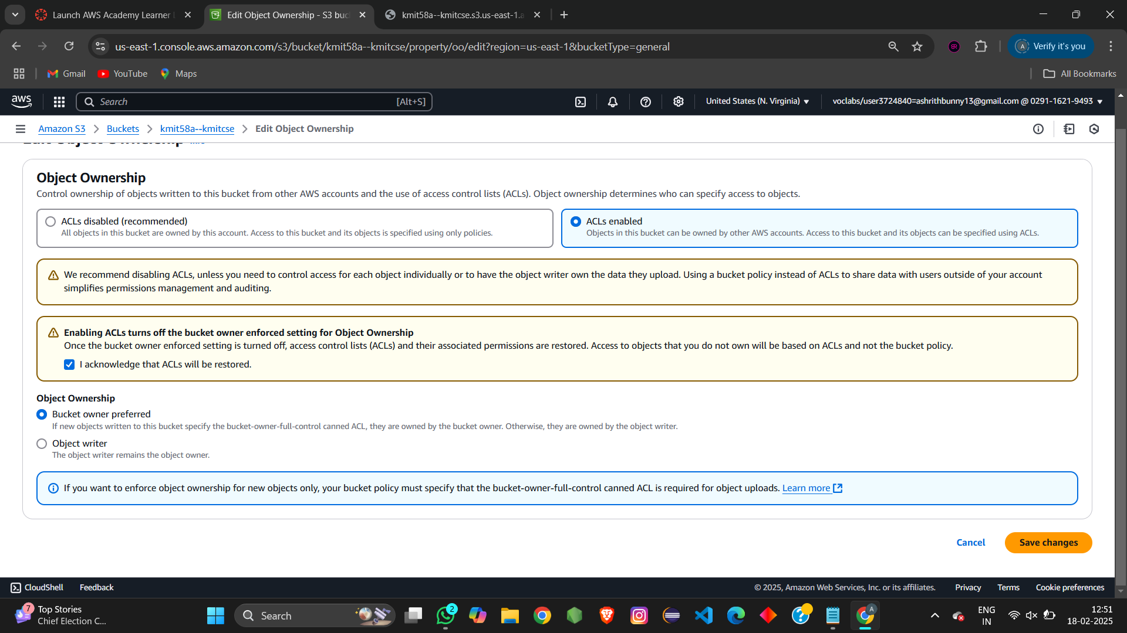

Edit access control list:

Checkbox the public access(public to everyone).Than save changes

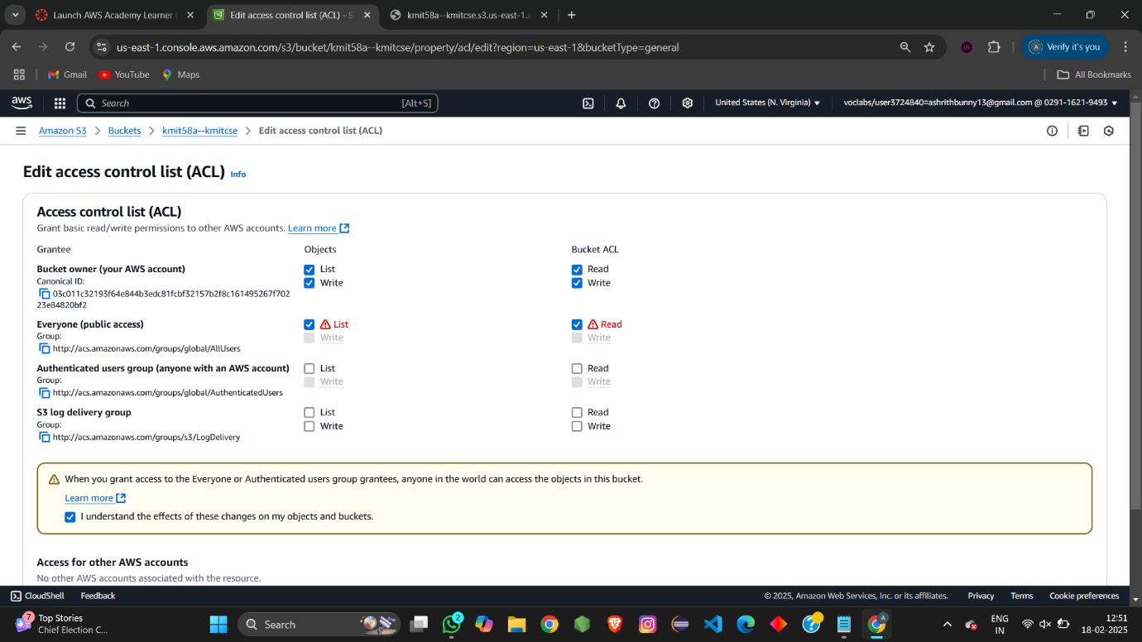

These are the changes to be done at Bucket – level permission.

After these changes still we are unable to access the object url because we need give permission at object-level .

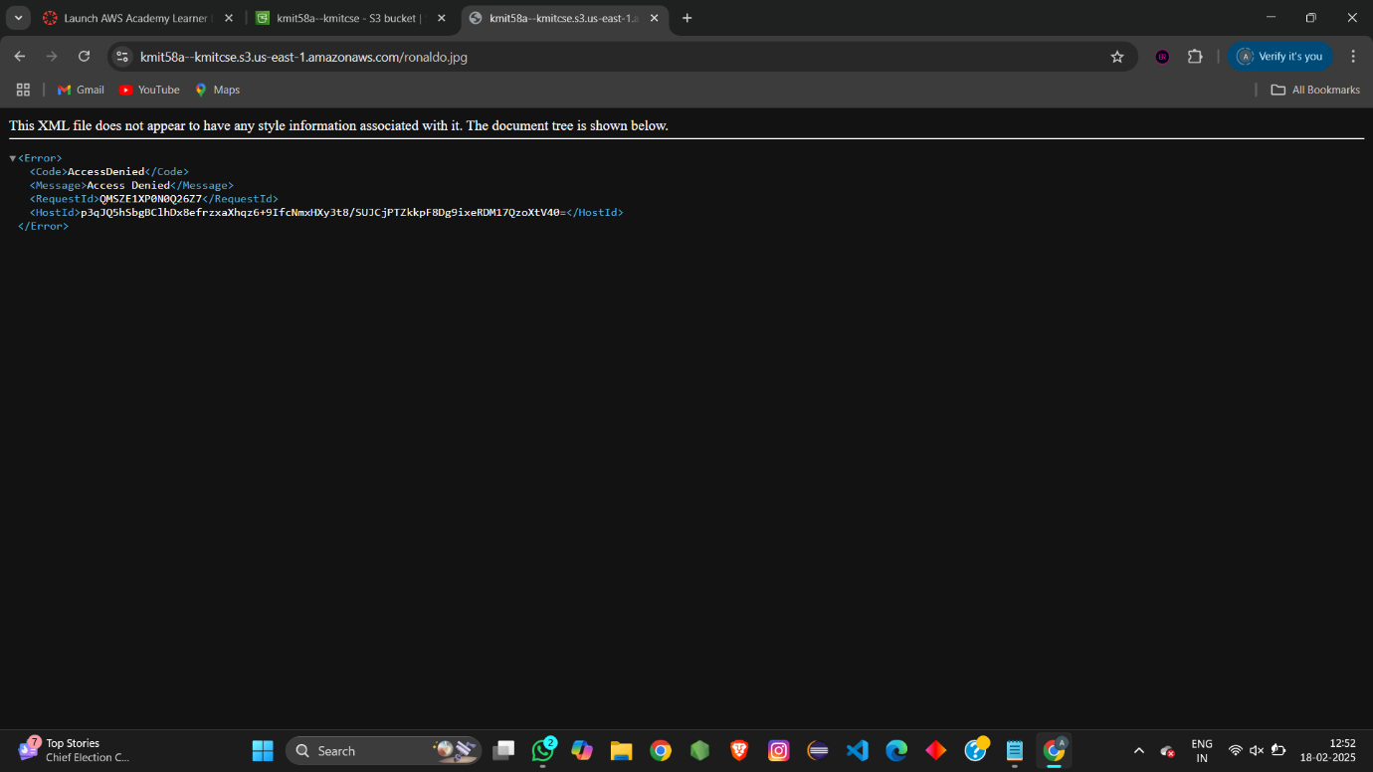

Object level permission:

Go to permission at Object – level

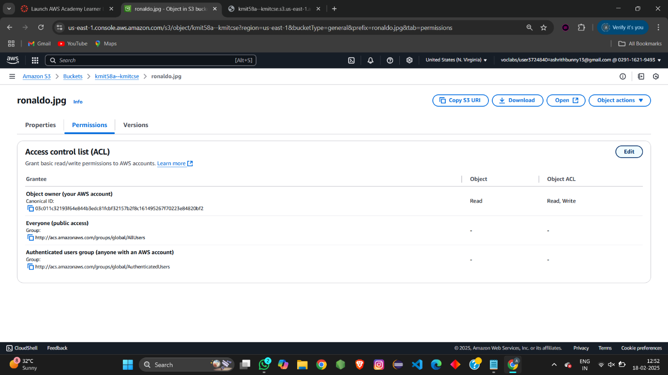

Edit the Acess control list(ACl)

Checkbox the Everyone(public acess),acknowledge the change --> save change

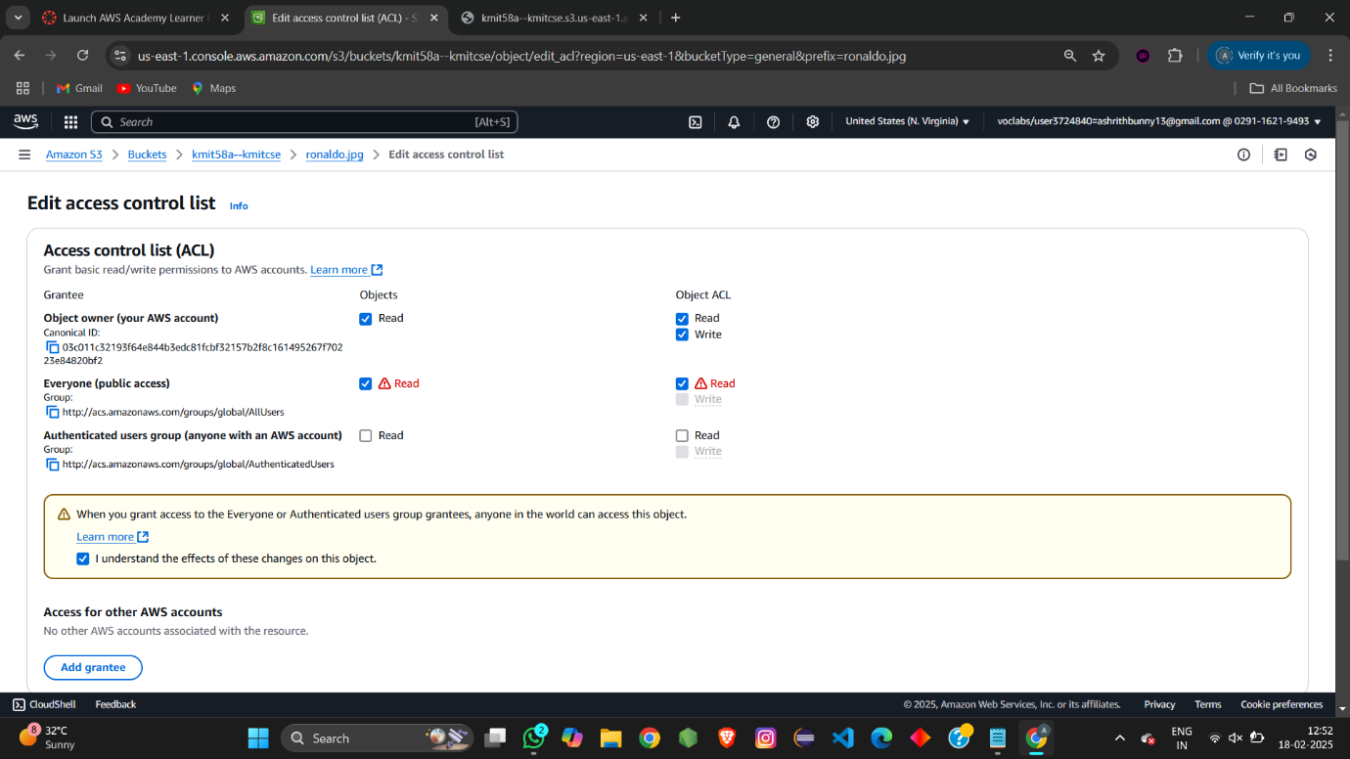

Now if you try to access the Object url .we are able to access it



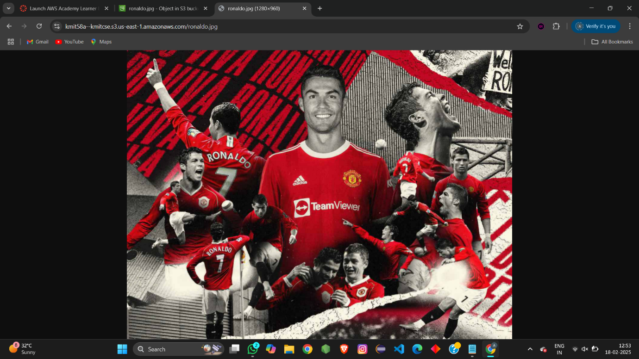

Object url:

<https://kmit58a--kmitcse.s3.us-east-1.amazonaws.com/ronaldo.jpg>

upload index.html

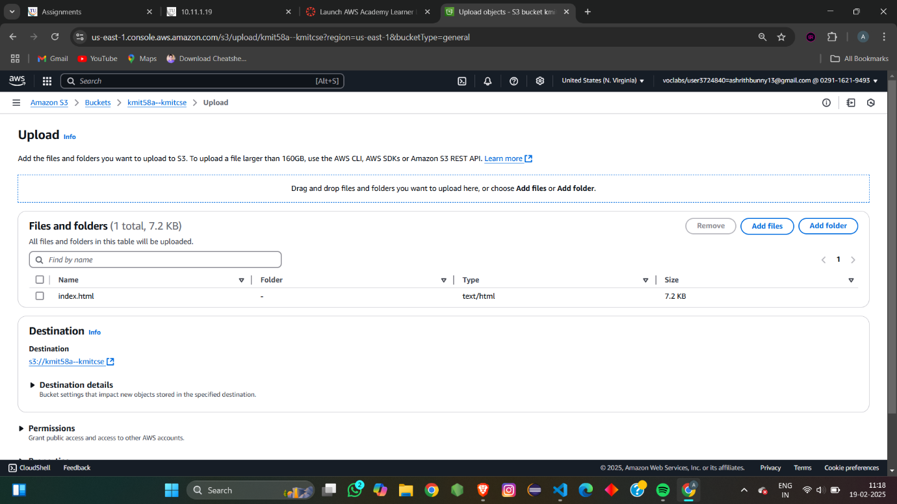

Edit the object level permission for index.html

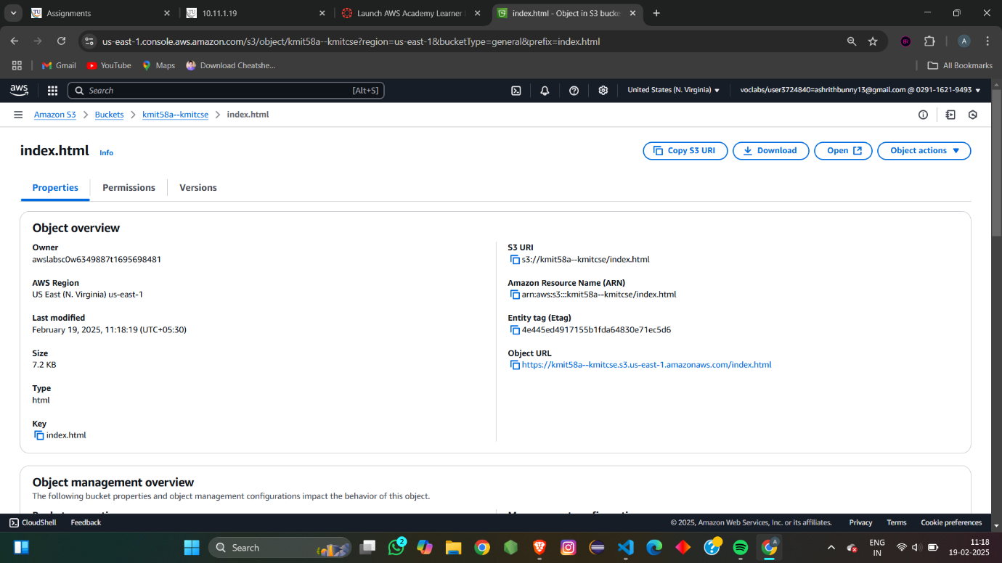

Acknowledge the change ,save change

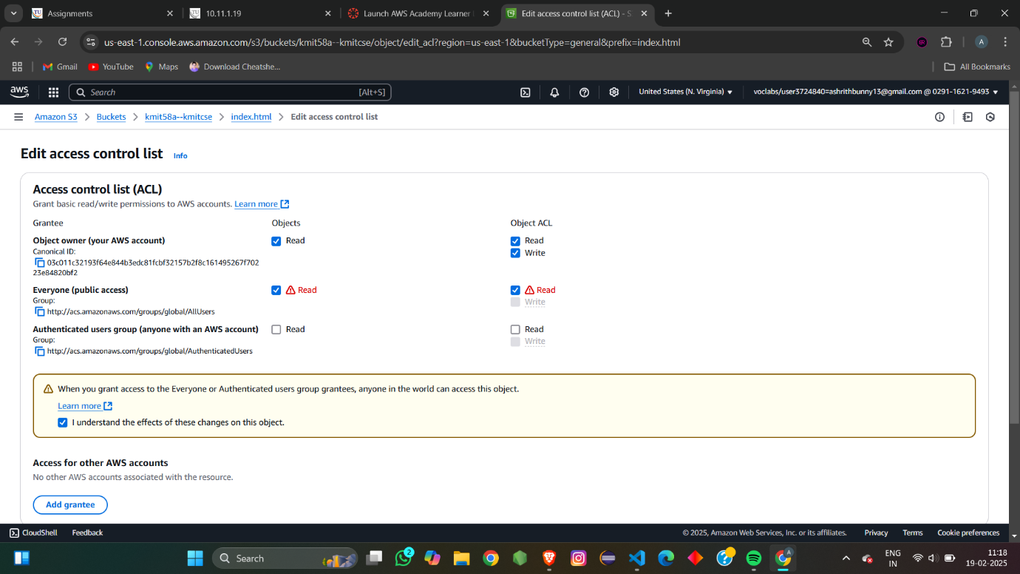

Portfolio.html url:

<https://kmit58a--kmitcse.s3.us-east-1.amazonaws.com/codsoft_task-2/index.html>

